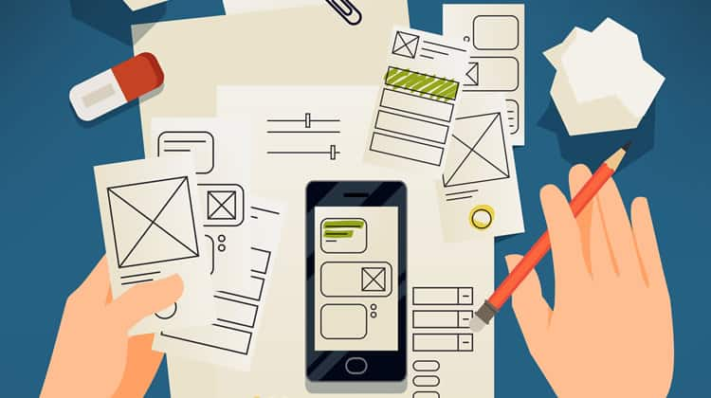
Prototyping Project
Author : Razan Tareef Alkhanji
Contents
1- Different Forms of prototyping 2
1.1 Discuss the different forms of prototyping, their purpose, their advantages and disadvantages, their testing outcomes. 2
1.2 Review the Standard Prototyping tools by providing a brief explanation about each tool and how they can be used in identifying and testing user requirements effectively. 2
2- Review different end user categorizations, classifications and behavior modelling techniques. 3
3- Examine available prototyping methodologies to test with a specific end user from the user population. 3
4- Prototyping Plan 3
4.1 Generic Description of Your Product Idea That Is Being Developed. 3
4.2 Identify your product end users by choosing the suitable end user categorizations, classifications (Segmentation, persona canvas, The value proposition canvas, customer journey map….) and behavior modelling techniques (BJ Fogg’s Behavior model), choose the suitable ones not necessarily all of them. 3
4.3 Determine the suitable methodology (Rapid throwaway prototype Evolutionary prototype Incremental prototype Extreme prototype), choose the suitable one. 3
4.4 Outline the right tools to prototype your idea (example, JustInMind, Figma, Mockups…) 4
4.5 Plan your prototype evaluation methods (Testing methods: Usability Testing, Focus Groups, beta Testing, A/B Testing, Surveys), choose the suitable ones not necessarily all of them. 4
5- evaluate the impact of common prototyping methodology within the software development lifecycle. 4
6- Low-fidelity Wireframe 4
6.1 Wireframes screenshots before applying feedback. 4
6.2 Iteration 1 4
6.2.1 Feedback – outline the end users’ feedback on the first iteration of your wireframe. 4
6.3 iteration 2 5
6.3.1 Feedback – outline the end users’ feedback on the second iteration of your wireframe. 5
6.4 Screenshots after applying feedback (of the updated wireframes only) 5
7- Mid-fidelity Mock-up 5
7.1 Mockups screenshots before applying feedback. 5
7.2 Iteration 1 5
7.2.1 Feedback - outline the end users’ feedback on the first iteration of your Mockup. 5
7.3 iteration 2 5
7.3.1 Feedback- - outline the end users’ feedback on the second iteration of your Mockup. 5
7.4 Screenshots after applying feedback (of the updated mockups only). 5
8- High-fidelity Prototype 6
8.1 Outline the added features to build your high-fidelity prototype. (What are the interactions, validations added to your prototype to make it similar to the final product) 6
8.2 Review end-user feedback from multiple iterations of your prototype and justify the updates to the final prototype based on end user feedback and testing. 6
9- Critically evaluate the prototype against the original plan and how user feedback and testing was implemented. 6
References 6

Different Forms of prototyping

1.1 Discuss the different forms of prototyping, their purpose, their advantages and disadvantages, their testing outcomes.

There are four different form of prototyping each of them has it’s own purpose, and I will define each one:
1. Low-Fidelity User Prototypes:
- Purpose:
- We usually use this form of prototype to reach out for ideas from the users during the early stages, to get early user feedback and to explore initial concepts.
- It is also used to asses how the flow is in the process (workflow), and what benefit is offered and how the whole usability is.

- Advantages:
- It is easy, quick and cheap to make as well (e.g sketches, paper prototypes, and wireframes).
- It is helpful in identifying usability problems before going forwards with the development phase.
- Easy to modify depending on user feedbacks.
- It facilitates a design process which entails revision according to feedback by users.

- Disadvantages:
- It lacks realism; sometimes it is difficult to imagine the final outcome.
- Limited interactivity (for example: static wireframes).
- Doesn’t let you see whether the proposed design, so it not suitable for testing technical feasibility or detailed UI interactions.

- Testing outcomes:
- make sure that user requirements and major user engagement are being met.
- Reveals gaps in workflow or UI.

2. High-Fidelity user prototypes:

- Purpose:
- it is used to engage viewers more experiencing how the final product would work in both visually and interactively.
- Considerate the in-depth user interface design UI, experience of user UX, and necessary characteristics.

- Advantages:
- It enables a lifelike interactions, like clicking buttons on Figma designs that I am going to use for my application (Personalized Perfume Builder App).
- There is a good understanding on what the finished product will be like.
- Unearths specific issues in UX, e.g. the ability of the user to use text or have access to buttons.

- Disadvantages:
- It takes time and cost to develop.
- Visitors could anticipate that the finished product would be 100 percent a functional as the prototype which is not true.
- Unwilling to make major changes on user input.

- Testing outcomes:
- Validates that the design of the UI/UX is functional, and measures response from the user.
- Finds flaws in the design’s look and feel and user interaction.

3. Feasibility Prototypes:

- Purpose:
- Evaluate the possibility for major functionalities such as the algorithms, the system performance and its capability to support the increase in usage (test technical viability).
- And to answer this question: “can this be built with current technology?”.

- Advantages:
- It reduces technology-related risks by showing the basic performance of the system.
- Generates frugal code that regards speed proof-of-concepts (Poc) before refined functions.

- Disadvantages:
- No user interface; limited to backend testing.
- Software built purely for evaluations, not for usage.
- Requires engineering resources.

- Testing Outcomes:
- Confirms technical constraints and measure performance.

4. Live-Data prototypes:

- Purpose:
- Use real data of actual users for functionality and real-time usage-based user experience.
- Show if a concept works in practical life situations (how users take to the feature, how accurate the data is).

- Advantages:
- Test real-world user behaviors and gather useful data.
- Identifies scalability issues early.

- Disadvantages:
- Resource-intensive (requires backend integration).
- Does not correspond to the standards of manufacturing (lack of security features and localization support).
- Availability is limited to few beta testers or not all users.

- Testing outcomes:
- Shows whether the market has actual demand to customize perfumes.
- Monitors system efficiency in real time scenarios.

1.2 Review the Standard Prototyping tools by providing a brief explanation about each tool and how they can be used in identifying and testing user requirements effectively.

Prototyping tool is used by designers and developers to create functional product prototypes for the purpose of user need evaluation, process testing and design viability assessment.

(1) Adobe XD:
- Description:
A strong prototyping tool, offering advanced interaction functionality, is fully interoperable with the Adobe Creative Cloud.

- How It Tests User Requirements:
High-fidelity interactions: Lends itself to the testing of user engagement using realistic animations and the transition effects.

Real-time collaboration: The capacity for stakeholders to have a look over and provide opinions ensures that user needs are easily introduced to the prototyping process.

Device preview: It is possible for evaluation of responsiveness in different operating systems and desktop and mobile environments.

This tool is best for polished prototypes for stakeholder presentations and for testing complex interactions like micro-interactions and transitions.

(2) Figma:
- Description:
Figma enables teams to work together effortlessly in the cloud, prototyping and testing and updating digital products in real time, accelerating the design cycle. Due to its flexibility, it is perfectly suited for discovering and verifying the needs of the users in the whole design process.
- How It Tests User Requirements:
- Real-time collaboration: Users and teams can work with each other in real time, making edits, providing feedback as they work.
- User testing integrations: There are tools that make usability testing easier like Maze and User Testing.
- CSS inspection: The design-to-code process is made easier to do because if feasibility is checked earlier, it becomes more streamlined.

- Figma is very suitable for remote teams needing seamless collaboration and promote rapid change with instant user knowledge.

(3) Balsamiq:
- Description:
This tool is usually used for a low-fidelity wireframing tool; it focuses on simplicity and rapid ideation. Balsamiq works perfectly for wireframes and mockups.it is easy to use tool because it is just drag and drop.
- How It Tests User Requirements:
- Drag-and-drop elements: Quickly measures the sequence and structure of material in the interface.
- Minimalist design: Facilitates focusing on functionality rather than looks, reduces personal biases in first feedback.
- Export to PDF/PNG: Enables stakeholders to be shown wireframes before final design develops.

- When do we use it:
It is used in early-stage concept validation, and it is independent of their need to be designers, product managers and other such people can create wireframes.

Review different end user categorizations, classifications and behavior modelling techniques.

1. End User Categorizations & Classifications
They divide users by attributes to study their requirements and create better features.
A. Segmentation
User segmentation involves grouping people together by looking at various factors such as:
- Demographic Segmentation: Customers are divided through demographic segmentation, using age, gender, level of education and income.
For example, people aged 18–30 who are interested in fashion and beauty.

- Geographic Segmentation: By dividing users by their geographical location or area.
Such users live in cities throughout the country of Jordan.

- Behavioral Segmentation uses data about how users interact and behave with different apps or products.
For example, people who take pleasure in customizing items and then showing them off on social media.

- Lifestyle Segmentation: Groups People by their Typical Lifestyle, Characteristics and Interests.
For example, creative people prioritizing non-standard methods and their unique personality.

B. Persona Canvas
This is a tool used to create a fictional but realistic representation of a typical user. It includes:
- The person’s name, age, place they live and job
- Personal characteristics, motivation and goals
- Situations involving frustration, challenges and needs
- A brief biography that makes them seem like real people
Purpose: It supports designers and developers ”think like user” in considering what the user wants during the planning and development stages.

C. Value Proposition Canvas
It connects the user’s wishes and wants to the abilities of the product through recognition of:
- Customer Jobs: What the user hopes to accomplish through the product (emotions, day-to-day tasks or social reasons)
- Pains: Any setbacks or problems they experience
- Gains: The good results that they want to obtain
- Pain Relievers: The help pain relievers get from the application
- Gain Creators:Features that help create something of value or give users happiness

2. Behavior Modeling Techniques
Behavior modeling helps us understand how users act, behavior modeling tells us the reasons behind their behaviors and the triggers that make them perform tasks in the app.
- What is Behavioral Modeling?
Behavioral modeling allows us to observe and guess how people behave as buyers and customers. It lets businesses learn about user decision-making and what drives those choices.
Behavioral models tend to be used for the following purposes:
- Revise what the product offers to customers.
- Make the marketing and the app’s content more personal.
- Group users based on behavior for targeted experiences

- How Behavioral Modeling adds value?
- Helps both designers and developers learn what makes users behave a certain way and understand what motivates users.
- Gives companies a way to offer the right content and features.
- It allows businesses to make better decisions by keeping a record of user activities
- It makes things easier by working with what people have actually done.

- Applications of Behavioral Modeling:
Behavior modeling technique is used in different industries such as:
- Finance: To see if someone can be expected to get into debt and to foresee possible risks. (To predict risk and loan behavior).
- Marketing: It ensures the proper customers receive the latest offers.
- UI/UX Design: to improve the engagement based on user behavior when they interact/use apps or websites.

A. Behavior Model from BJ Fogg
This is one of the top UX-based behavior models. It states that a behavior only takes place when all three of these things happen:
- Motivation (M): Does the user want to do this?
Creating something special for themselves, being creative and expressing themselves are the main reasons users are motivated.

- Ability (A): Can the user do it easily?
The app provides simple guides, step-by-step design that doesn’t require any knowledge. For example like my website “Charming Scents” it does not require from the user to have a previous perfume knowledge.

- Trigger (T): Is there a prompt that encourages action?
Users are guided through the process because of easy-to-spot start buttons, progress bars and confirming messages.

B. Relevance Feedback
A system that adapts based on how users respond to certain features. If someone repeatedly picks floral fragrances, the system may recommend some similar fragrances.

C. Predictive Behavior Modeling
Using machine learning to forecast what a customer is likely to do. Makes it possible to anticipate how users will act later on.
- Are they able to put the perfume design together?
- Will the people return and create another?
- Will the user decide to save or share their feedback?
As a consequence, we can connect with customers in a more meaningful way and make the experience more engaging for them.

- Summary
By applying segmentation, persona creation, creating a value proposition map and studying behavior (like Fogg suggests), we can:
- Get a clearer picture of who our users are.
- Make experiences that are both meaningful and uncomplicated.
- Help users take action and stay engaged.

These techniques are very important in know who exactly our users and creating user-centered apps that are not only functional, but also emotionally satisfying and enjoyable to use.

Examine available prototyping methodologies to test with a specific end user from the user population.

When we want to test with a specific end user from the user population, it is important to choose the suitable prototyping methodology that aligns with project goals and user expectation.

(1) Rapid Throwaway Prototype
- Mainly seeks to accelerate the process of making prototype from early requirements.
- This prototype is a concept testing prototype and is usually discarded after stakeholders from providing input.
- This approach helps the developers to experiment testing various concepts without the need of committing to a design immediately. Frequently the prototype is a stripped-down vision of what the product will ultimately be, created in order to allow users to test and react. Once the opinions of the user have been collected, the prototype is normally disposed of, which is not a design to be long term used. This is particularly helpful if the initial goal and need of the project are not yet clear.
Advantages:
- In the timely development, users receive feedback in an approximate quick time frame.
- Facilitates the identification of design problems early on before large-scale deployment.
- Authorizes cheap changes at the beginning of product development.
Best Use Case:
Best used in the situations where specific requirements are absent and the rapidness of testing is a matter of relevance.

(2) Evolutionary Prototype
- An evolutionary prototype is a functional piece of software that evolves through incremental refinements based on user feedback.
- At first, the methodology is aimed at introducing a fundamental product that will meet only the requirements that have been clearly defined. While the prototype is tested by end-users, their feedback dictates the design of extra features and enhancements.

- This methodology allows the product to evolve incrementally and keeps pace with the shifting needs of the product’s base of users. An evolutionary prototype is particularly helpful in those cases where initial specifications of user demands are unclear.

Advantages:
- This methodology saves time as each iteration builds on the pervious iteration, so it allows continuous improvement and refinement.
- Supports the addition of new features when understanding of requirements improves to keep the solution current with changing user needs.
- Acknowledges that not all requirements are understood at the start, allowing for a more flexible development approach.
Best Use Case:
Perfect for projects in which changes in requirements are to be expected, such as project adaptation to technology or current user feedback.

(3) Incremental Prototype
Launch of the finished product is attained in an incremental prototype through the step-by-step design and testing of parts, which will only be assembled once each has been individually tested. This technique facilitates a shared effort of all parts across the project since several teams focus on various aspects at the same time. Each component is individually tested and improved to approve it in terms of meeting user needs before being assembled with other modules. For those systems that are heavily interdependent on their components, this method stands to gain especially.

Advantages:
- Makes it easier to absorb user feedback since one module can be adjusted without a delay.
- Allows development of autonomous prototypes which can be individually tested and verified before being blended for a complete system.
- Ensures collaborative outputs from development teams where there is tackling of several modules at once.
Best Use Case:
Most appropriate for enterprise software with a number of modules and we can do them in parallel, leading to clearer and more streamlined approach towards the development.

(4) Extreme Prototype
This methodology called extreme prototyping is particularly designed for the developing web applications. The process is broken down into three distinct stages :
1. Static Prototype: Here, the users are given an opportunity to see a static version of the interface built on HTML pages, therefore, without having to be affected by the back end functionality.
2. Functional Screens: On the second stage, users gain functionality as they interact with the screens as they share insights about usability and design.
3. Service Implementation: In the final stage, we have backend services developed to support the application capabilities to ensure flow integration between the UI and the back-end systems.

Advantages:
- Positioning the user interface at the heart, it makes sure that the usability is implemented first, and is a must have for success with web application.
- Promotes rapid development and testing cycles, which enables developers to quickly take incorporation of user feedback.
- Favors a systematic development approach to ensure that at all levels functions are installed in well-designed foundations.
Best Use Case:
A great tool in Web development where usability is key to encourage development thinking in terms of end-user.

Prototyping Plan

Generic Description of Your Product Idea That Is Being Developed.

The product idea is an interactive website called “Charming Scents”, which allows users to design or custom their own personalized perfume. What marks this project special is its capacity to blend creativity, looks-and-feels customization, e-commerce via a versatile tool that enables the user to custom a scent tailored to them.
Users follow a rather easy and step-by-step journey:
- The user will be able to choose the base, middle, and top notes which are to compose the scent.
- They can name their custom perfume.
- They can build an online model of their perfume bottle (shapes, colors, and labels).
- Save their created perfume in their account and order it.

The website provides an intuitive, beautiful, and emotionally immersive interface so that any person can become a creator of fragrances. Serving as a special feature in contrast to the traditional perfume stores, this one focuses on the autonomy of user and creative participation and is a new idea highly unavailable in the market.

Identify your product end users by choosing the suitable end user categorizations, classifications (Segmentation, persona canvas, The value proposition canvas, customer journey map….) and behavior modelling techniques (BJ Fogg’s Behavior model), choose the suitable ones not necessarily all of them. Minimum three (Persona, segmentation, value proposition)

To build a successful website like my website (charming scents), knowing the users of my website is very important. End users are the actual people who will interact with the website or application to custom and give names to their own perfumes. The end users aren’t always the people who purchase the product, but they do decide if it succeeds or not.
- To identify the users who will use my website, I have used these methods to discover and understand our users:
- Segmentation
- Persona Canvas
- Value Proposition Canvas
1. User segmentation
User segmentation means dividing the users into smaller groups based on shared characteristics. As a result, Marketing, and planning for the website features and how users will experience the app can be tailored to every group.
- Based on my website’s purpose, I used the following types of segmentation:

- Demographic Segmentation:
- Age: The majority of the users are from 18 to 35 years old.
- Gender: Mainly created for females, yet it is open to anyone.
- Education level: High school, University students, and graduates.

- Geographic Segmentation:
- Users living in urban areas from areas such as Middle East or Gulf states like Saudi Arabia and the UAE.

- Lifestyle Segmentation:
- Users who are interested in fashion, appearance, self-expression, and sharing online. And for who enjoy trying personalized products.
- Individuals who love unique products and customization.

- Behavioral Segmentation:
- Users who regularly buy perfumes, like personalized products, and share purchases on social platforms.
- Users who enjoy customizing things and get special gifts for special occasions.
Using segmentation enables me to direct my product design at a broad group that is also well-defined.
2. Persona Canvas
Making a realistic user profile allows the target user to become real and helps designers keep the focus on users.
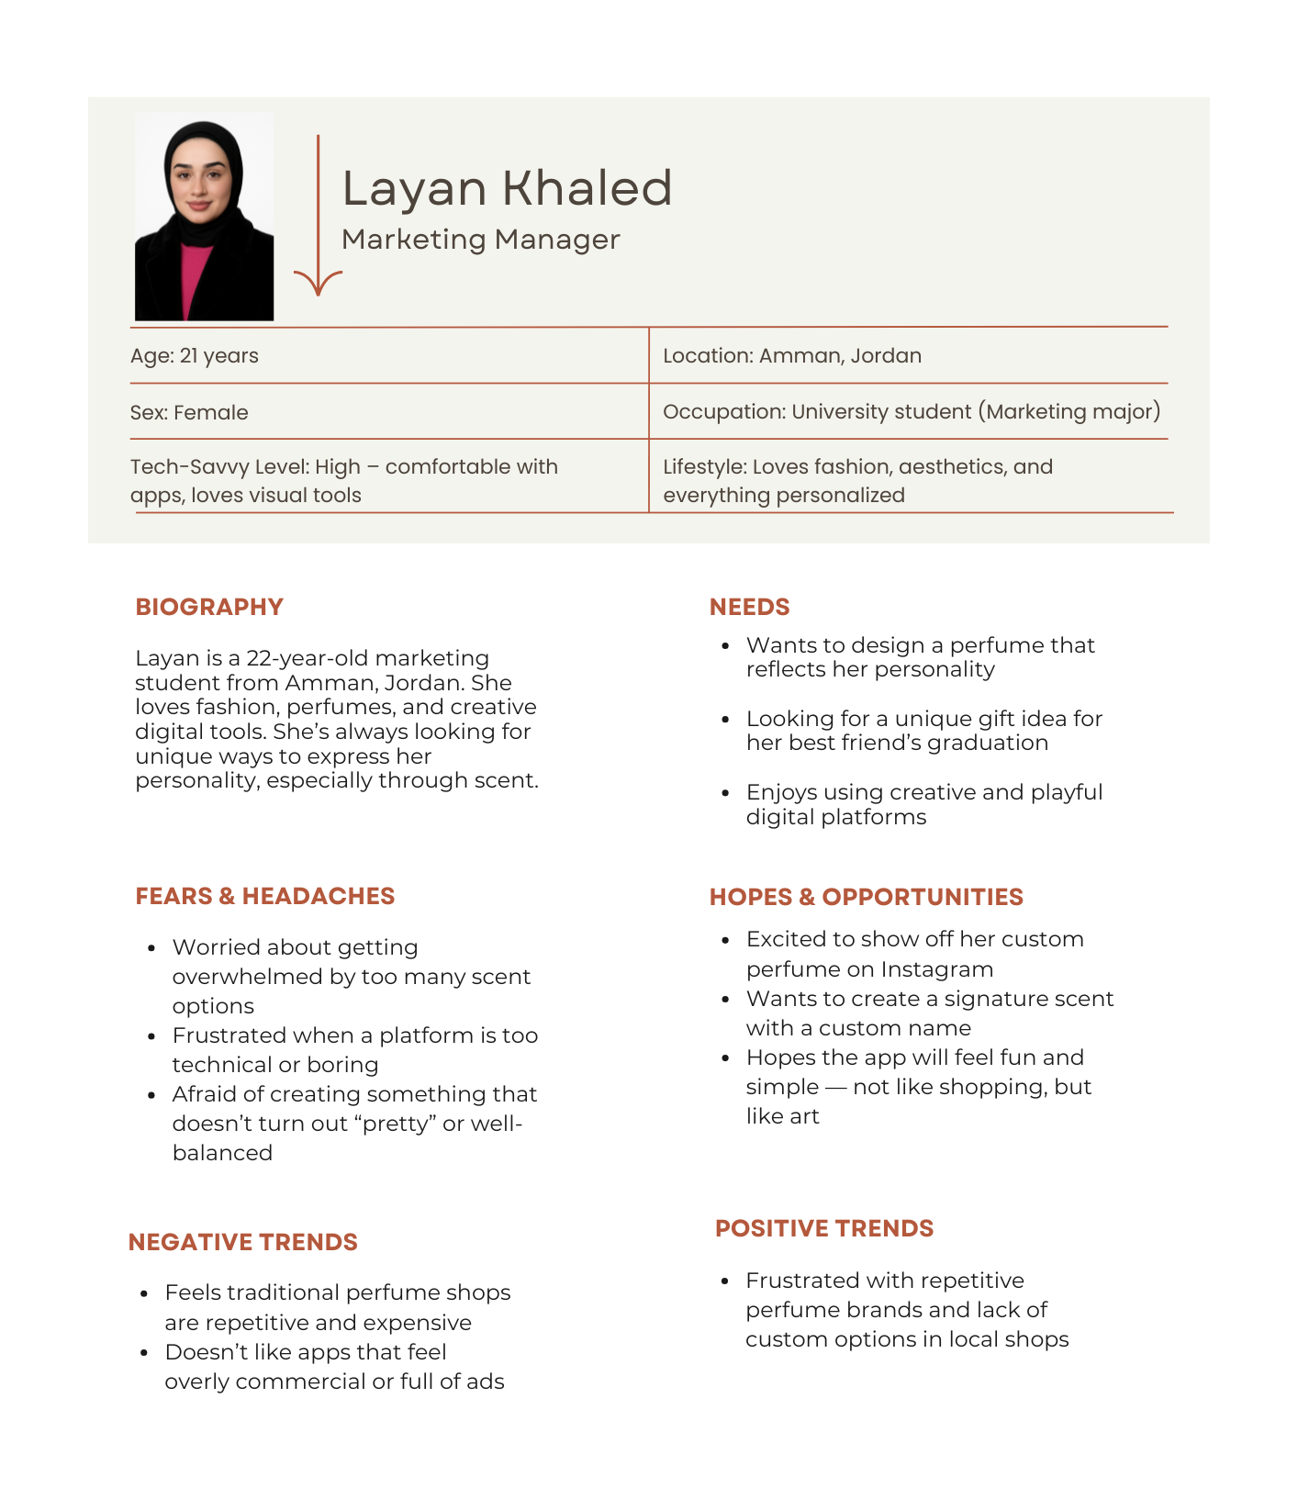

3. Value Proposition Canvas
Using this method made it easier to match the product’s features with what matters most to the user.
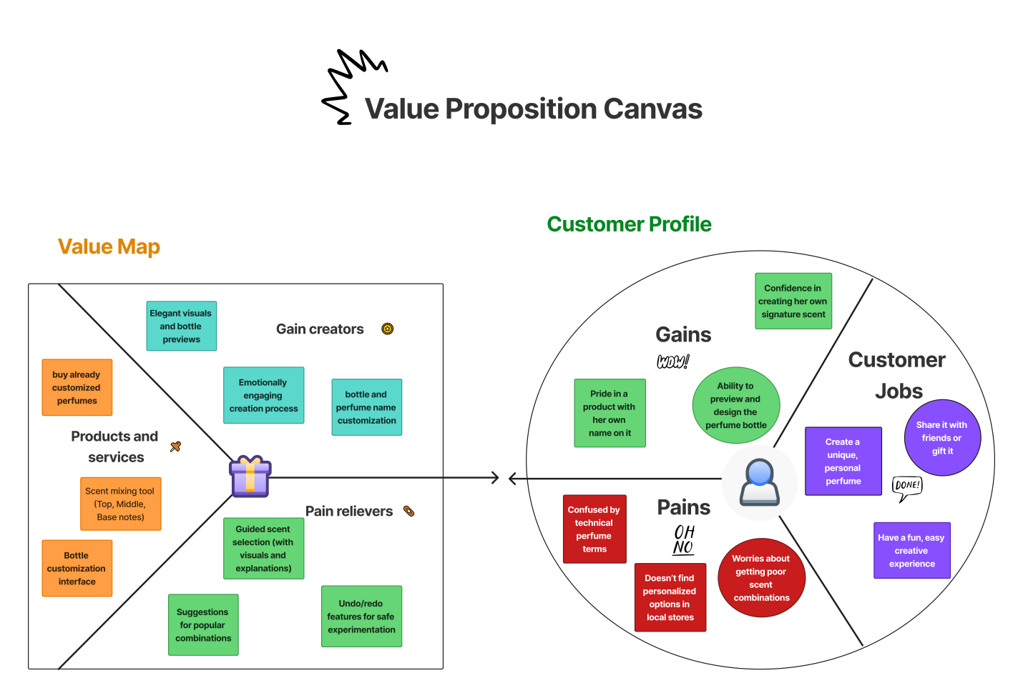
- Summary
Applying segmentation, making a persona canvas and a value proposition canvas has helped me clearly understand my main user: a Jordanian young woman who enjoys being creative, open and experimenting with digital offers. Knowing this will help every design choice so that the app is familiar, helpful and enjoyable for everyone.

4. Behavior Modeling Technique (BJ Fogg’s Behavior model)
The BJ Fogg Behavior Model shows how to make sure users will use my product when it matters most. When Motivation, Ability and a Prompt happen at once, behavior is said to occur according to the model.
I designed Create Your Own Scent with clear-cut BJ Fogg’s Behavior Model steps, since it helps achieve things by teaching how and why users are encouraged to perform certain actions.
For something like designing a perfume to happen (according to Fogg), there must be motivation, ability and a trigger present at the same time.

- Motivation (M) – Why are they interested in personalizing their own perfume?
- The purpose of motivation in this app is to let users express themselves, be creative and feel distinct.
- Represent their personality: Developing a site that displays their character is something users become emotionally attached to.

- Ability (A) – How easy is it for the user to perform the action?
The app guides users step by step to make things simple:
- Selecting scents by going through each option Anton provides
- Bottle personalization using designs
- Easy way to name and save your data
It eliminates any problems that could stop new users and lets them achieve their goals.

- Trigger (T) – What pushes the user to take action now?
There are triggers within the app, for example:
- There is a “Start Now” button placed clearly on the homepage.
- Having progress indicators on each step (e.g., Step 1 out of 4) motivates users to finish.
- Minimal distraction: each page that I designed helps users to focus attention on task at hand-making the next step feel clear and simple.

- How This Helps supports the website’s UX:
- Motivation: Getting motivated begins when something we build brings us happiness and a unique meaning
- Ability: Learning the tool only takes a little time because its interface is so simple (smooth interface).
- Trigger: Prompts that guide users to begin or complete their perfume
Since the app uses Fogg’s model, the app ensures users not only want to engage but are also able to do it easily, and feel encouraged to act.

Determine the suitable methodology (Rapid throwaway prototype Evolutionary prototype Incremental prototype Extreme prototype), choose the suitable one.

After understanding the nature of the project, I just found out that it is focusing on user experience and customization, so the most suitable methodology for this perfume builder app is the evolutionary prototyping model.
- Why evolutionary prototyping:
- User engagement is crucial because the website is built to be extremely sensitive to user feedback.
- Users might react differently for scent choice, bottle, customization, or design layout, so we need to be able to adjust and improve the prototype continuously.
- Since this is a new departure, it’s possible for some aspects to change or be modified as we collect feedback.
- Reusable components can be improved for every iteration — the scent mixer and virtual bottle preview can be improved, rather than discarded and rebuilt from the ground up.

- What it looks like in practice:
- Develop a prototype with main functionalities, (ex. Scent selection and name creation).
- Show the prototype to users or testers in order to get their opinions.
- Request feedbacks from users or testers on usability, visual design and operational logic.
- Refine and elaborate the application (with the inclusion of bottle design elements, animations and saving preferences to profile).
- Then continue to develop the app until all features are running smoothly and it feels done.

Outline the right tools to prototype your idea (example, JustInMind, Figma, Mockups…)

- I chose (Figma) to create the prototype of the “create your own scent” – personalized perfume builder app.

- Why Figma?

- User-Friendly Interface: Its clear and user-friendly design tools in Figma assists beginner to see and develop designs without previous expertise for UI/UX.

- Cloud-Based Collaboration: Since Figma is cloud-based, I can access my designs whenever I want it, simply accessing my designs from any device allowing for easy collaboration with instructors, classmates, and future testers for immediate feedback.

- Interactive Prototyping: The tool allows me to create user interfaces that are responsive to clicks so that users may test the app within its features. Users have access to the preferred scents they can choose from, bottle option modifications, and test the sampling of app navigation as if they used the final product.

- Design Flexibility: Figma’s strong plugin catalogue and configurable options let me draft complex interfaces, from icons through to draggable figures and bottle sketches that feature a real perfume brand’s aesthetics.

- No Installation Needed: As a browser tool, Figma calling does not require any installation and stays fast and available on all devices.

Plan your prototype evaluation methods (Testing methods: Usability Testing, Focus Groups, beta Testing, A/B Testing, Surveys), choose the suitable ones not necessarily all of them. Minimum three

- To ensure that my website meets the user expectations and offers a smooth, enjoyable experience, so I am planning to evaluate the prototype using three main testing methods:

- Beta Testing
Description:
Beta testing is all about providing a group of users with the high-fidelity prototype and inviting them to play with the experience as long as it was a real product. These users pretend to actually use it without instructions and give their feedback once they have gone through the journey.
What I will consider:
- General convenience of use throughout the process
- The way users will respond to the final design features such as scrollable perfume line, preview of the bottle and confirmation messages
- Technical or imaging problems that were not apparent in earlier steps
Why it’s useful:
Beta testing offers a final development check before development. It provides an estimation of the way the real users will interact with the product and assists in ensuring that the prototype is usable and pleasant. It also unveils last minute problems which might not manifest in cases of structured tests.
- Usability Testing
Those selected are to go and use the prototype in carrying out the intended activities among other things such as:
- Choosing perfume notes (top, middle and base).
- Naming their perfume
- Designing the bottle
- Completing the process In this process, I will listen to how they respond for me to determine:
- Any confusing steps
- Points where users hesitate
- Responses given by participants during or after the test sessions

What I will consider:
- Users reluctant, difficulties, confusion
- The feel of the flow of the experience as natural and clear
- See how the users will react verbally and visually while using the website
Why it’s useful:
Usability testing is a method that assists in identifying friction in real-time user journey. It can help me to make specific design refinements, based on the way in which people actually use the prototype, not on assumptions.

- A/B Testing
In case of having an opportunity, I will design two alternatives of an important app element (scent selection layout/ bottle customization page) and let participants compare both of them. Then I will evaluate the results in order to determine which design should be executed.

A/B testing makes it possible to create informed design decisions that embody what end-user finds good about interacting with the platform, so A/B testing helps in making data-driven decisions based on what the user prefer in the real interactions.
What makes it useful:
A/B testing can help me to make design decisions confidently using real user behaviors. It minimizes the element of guesswork and assists in selecting the most efficient one to be used in the final prototype.

Usability Testing, A/B Testing, and Beta Testing used together will enable me to collect qualitative and quantitative feedback. Such approaches help make sure that the prototype will be tested under a variety of perspectives, including step-by-step usability, side-by-side comparison, and end-to-end simulator, which will help to finalize the product that will be intuitive, easy on the eyes, and based on the actual user requirements.

evaluate the impact of common prototyping methodology within the software development lifecycle.

Prototyping plays a significant role in improving the software development process within SDLC. One of the best benefits is that it gives the developers, designers, and stakeholders an opportunity to visualize the product before the development process is initiated. Instead of spending considerable time putting out comprehensive specifications upfront, the prototyping provides an early making way for an interactive prototype that both the developers and the users can interact with.
The most applicable models in this project were Rapid Application Development (RAD) model and Prototyping Model. Both agvesely depend on the process of creating fast prototypes, trying them with users, improving them and iterating. This process helped me to be more flexible, respond to user feedback, and refine the design in an iterative process.
RAD assists the creation of work versions of the system iteratively. Such versions (or prototypes) are continuously being tested and refined depending on the feedback by the users. That means, rather than having to wait until the end of the process to find out whether the product is coming along nicely, RAD allows developers, as well as users, to view progress and outcomes early.
The approach promotes rapid iteration, agility and constant iteration, which is particularly helpful in creative applications such as yours where user interaction and personalization (such as creating a custom perfume) is the primary goal.

The impact of using the right prototyping methodology can be seen in several key areas:
1. Improved Requirements Gathering
Prototypes help refine ambiguous or incomplete requirements, so that they are well understood. The visual representation of stakeholders and users at the beginning aids in recognizing as well as addressing any possible misunderstandings before the commencement of development begins. At the end, this process leads to less changes required in the plan during implementation stage.

2. Better User Involvement and Feedback
Examples of methodologies that include frequent interaction with users during the prototyping phase include evolutionary or throwaway prototyping. Engagement throughout the process means that the product fits the requirements of the users better – this results in increased satisfaction and decreased failure of projects.

3. Reduced Development Time and Cost
Identifying and correcting design or usability error at the prototyping stage saves from many costly mistakes in the future. Dealing with a problem with user interface at a prototype level is extremely cost effective than done at the end of development. This eventually leads to increased efficiency and cost saving as a project develops.

4. Enhanced Communication
Prototypes reflect a common understanding between technical and non-technical stakeholders. Personally studying a visual prototype of a project provides stakeholders better insight on project ideas than just reading technical specifications.

5. Encourages Iterative Development
Through the use of such methodologies as evolutionary or incremental prototyping, the project progresses by circular progressive steps. The product eventually becomes better with each upgrade with respect to quality and usability.

- Use of the Prototype in Each SDLC Phase
1. Requirement Gathering and Analysis
- Effects of Prototyping:
Prototyping was used to determine user needs early, although the users themselves did not know what they wanted in terms of features initially. I did not collect extensive specifications but rather built a rough draft of the app and used it as a means of communication and requirements refinement by visual means.
- How It Was Applied in My Project:
I created low-fidelity wireframes demonstrating the basic flow (choose scents, design bottle, name perfume). These initial screenshots were used to understand what the users desired and influenced the functions of the app, including adding tooltips, improving the design of the scent selection, and dividing the space between Shop and Create.
From the beginning, users can make their views known thus reducing the chances that of mistaken communication and also the product will meet their demands. This way, the likelihood of later costly fixes will be reduced, as any changes can be made incrementally out of actual user feedback. When usability problems and errors are identified earlier, developers make sure the product is both user-friendly and reliable once open for use.

2. System Design
The uses of prototyping:
- Med-fidelity mockups serve the purpose of pre-development testing of UI/UX design decisions.
- The arrangement, colours, typeface and the position of elements are tried out on users.
- At this point prototyping is used to select the optimal design variant by means of A/B testing or usability testing.
3. Implementation (Development)
- How prototyping is used:
- High-fidelity prototypes can be used as a guide to developers.
- Interactive prototypes imitate functionality, and it is less challenging to transfer the design into the code.
- Developers can even develop the prototype into a working system incrementally in case they are using the RAD model.

- In my project :
- My last high-fidelity prototype (made in Figma) had click-through interaction, progress bars, input field validation, and bottle preview.
- These components were a reflection of the manner in which the actual system was supposed to perform.
Impact:
- Better communication with future Developers.
- Fewer coding mistakes as the layout, interactions and flow were already verified and specified.

4. Testing
How prototyping is used:
- The prototype is tested with real users prior to releasing the final system through beta testing or usability testing.
- It assists in revealing possible usability problems, issues with the navigation, or ambiguity of the steps.
- The prototype will become a simulation of the end testing before the development is finalized.
In my project I:
- I tested my high-fidelity prototype with users through a beta test.
- Feedback allowed me to correct the issues with scroll areas that were not clear, add confirmation messages, and enhance mobile responsiveness.
Impact:
- Identified and resolved UX issues prematurely.
- More confidence on the usability of the product prior to the construction of the actual system.
5. Deployment & Maintenance
The uses of prototyping:
- Even after the final product has shipped, initial prototypes can be used to contrast what was planned against the shipped version.
- Prototyping New features can be prototyped, tried out on users, and then integrated into the system in subsequent updates.
In my project I:
- The app is not yet released; however, it is possible to test the future add-ons, such as a login system, payment flow, or scent suggestions using the prototype.
Impact:
- Enables the on-going development of a better product even when it has been launched.
- Minimizes the risk during upgrade of the live system.
Conclusion
The benefits of prototyping are profound and positive on all phases of SDLC. It helps:
- Collect superior requirements
- Create more effective design
- Enhance developer understanding
- Minimize programming bugs
- Be highly usable
- Construct systems that are desired by users

Low-fidelity Wireframe

6.1 Wireframes screenshots before applying feedback.

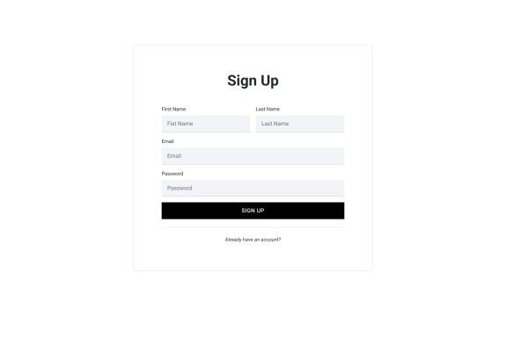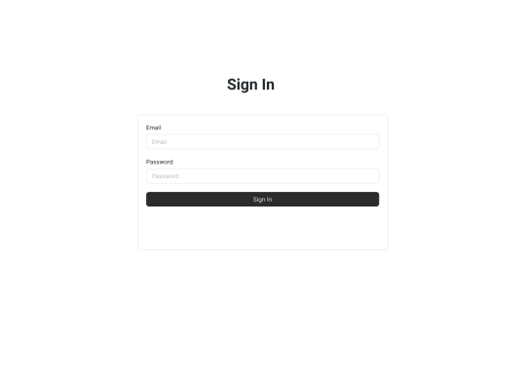
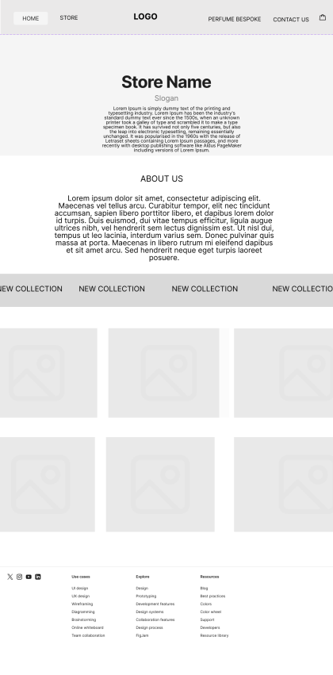

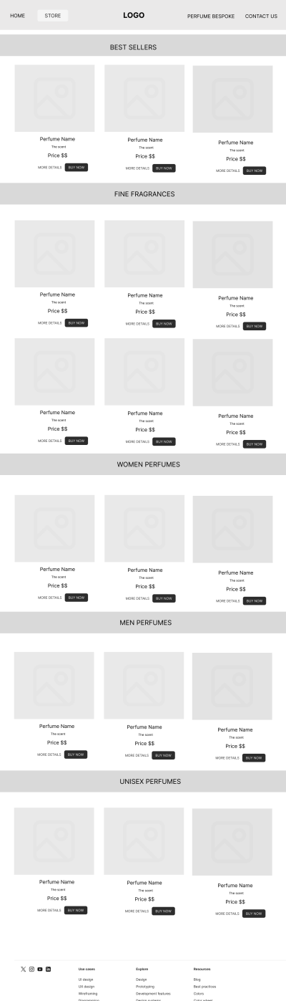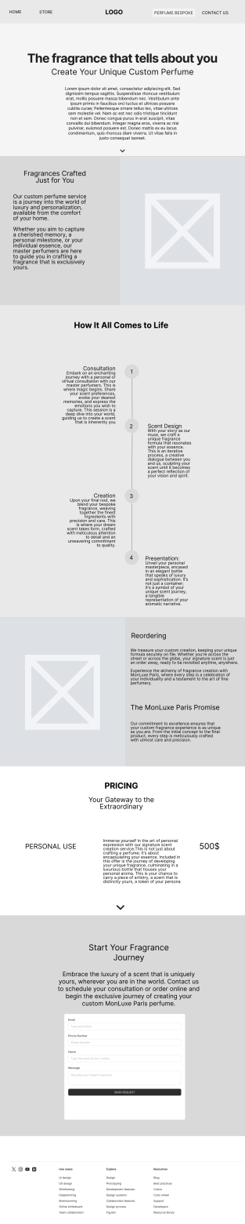
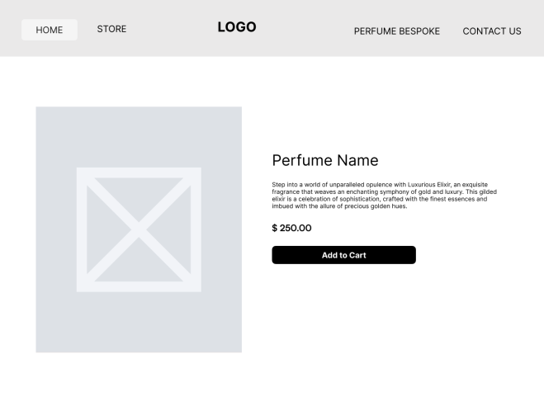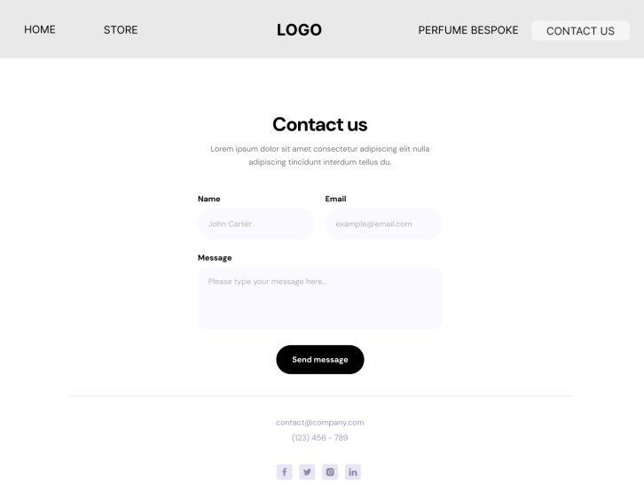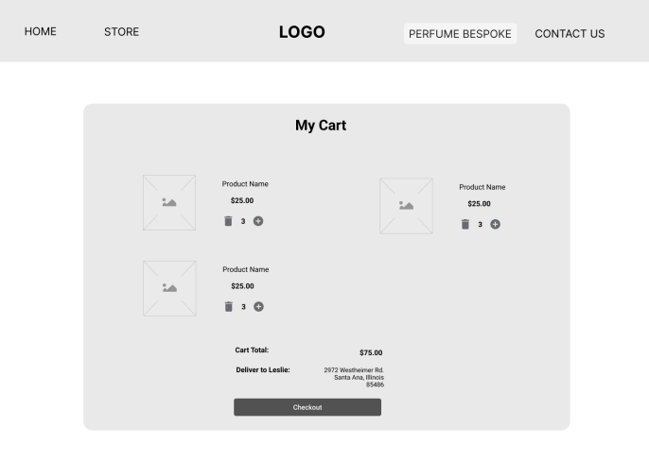

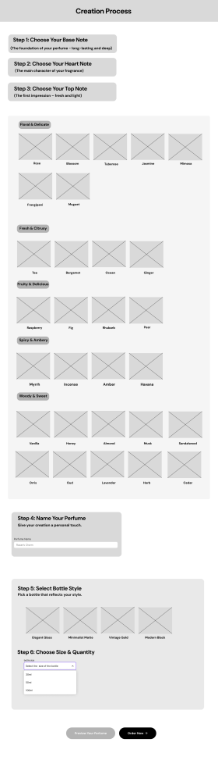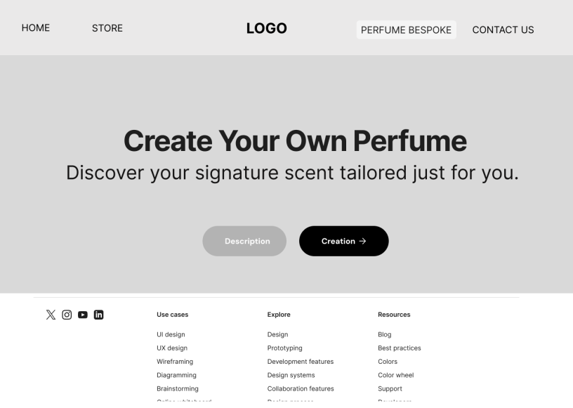

6.2 Iteration 1

6.2.1 Feedback – outline the end users’ feedback on the first iteration of your wireframe.

I have collected from users to get the feedback in three different methods (some are university students and some are young adults).
- Home page:
Although the homepage is appealing, users say it’s necessary to make the “Start Customizing” button more noticeable to guide them immediately into the main feature of my website.

- Bottle Selection:
Most users wanted to have a look at their bottle before they were able to purchase it.
- Navigation:
Some users felt distracted because there wasn’t enough clarity when browsing the customization part and products page. They asked for clearer navigation and separation between “Shop Perfumes” and “Create your Own Scent”.

6.3 iteration 2

6.3.1 Feedback – outline the end users’ feedback on the second iteration of your wireframe.
After the group reviewed the first wireframes, they received updated ones to go over again.
- Homepage Button Added:
After adding the “Start Customizing” button that helped the users to navigate quickly. Most users said that this made the website’s offerings simpler to comprehend.
- Bottle Preview:
Seeing how the bottle will look using the customer’s design was very popular. Many said the easier it was to feel involved and like they were taking part in the action.

- Navigation Structure:
Having the menus labeled “Shop” and “Create” instead of “purchasing” and “designing” solved much confusion. People using the product liked that the two options were separate even though they were both there.

6.4 Screenshots after applying feedback (of the updated wireframes only)
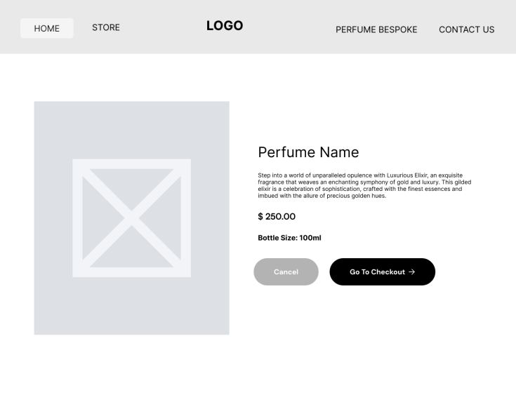
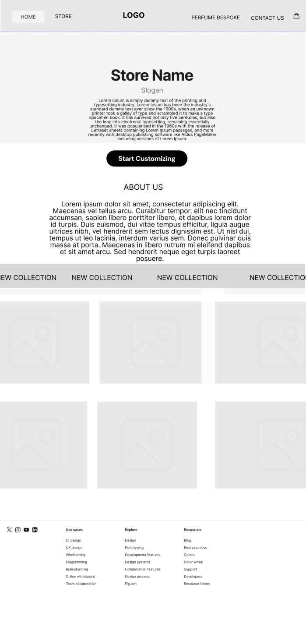
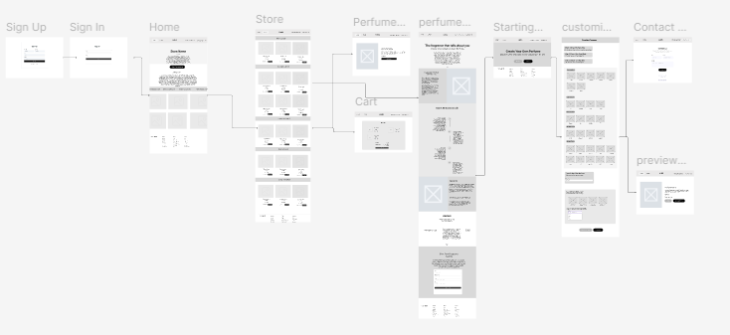

And here I showed the flow of the website so they won’t get lost.
The updated wireframe lets users step through the website in an easy and entertaining fashion. From start to finish, the process is well designed and gives a feeling of being in control.
- The flow of the website now feels natural and empowering.so, Users can now:
- Understand the purpose of the website instantly
- You can go easily from the shop to the customization screen.
- Follow some basic and enjoyable steps to make their own perfume.

Mid-fidelity Mock-up

7.1 Mockups screenshots before applying feedback.
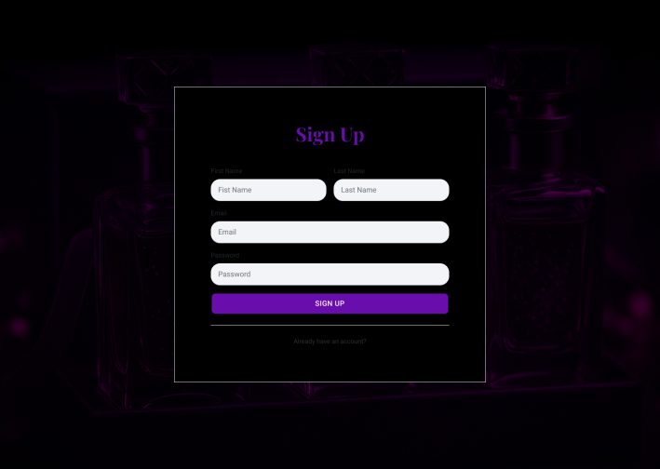
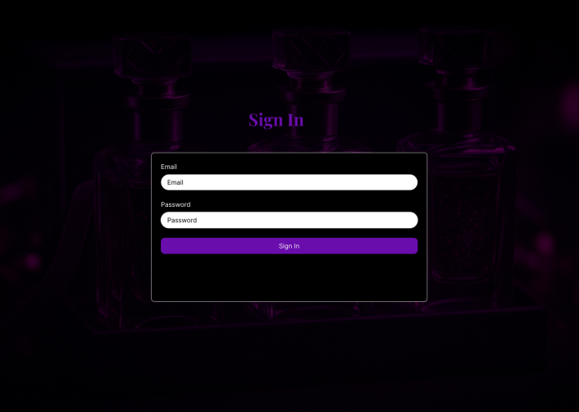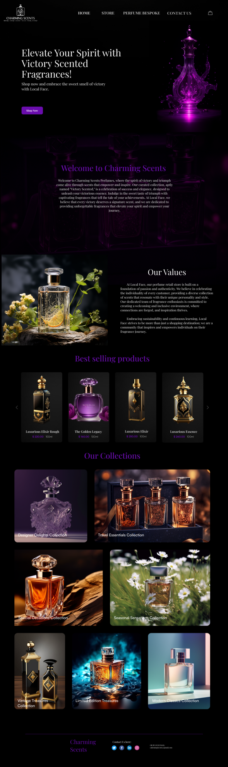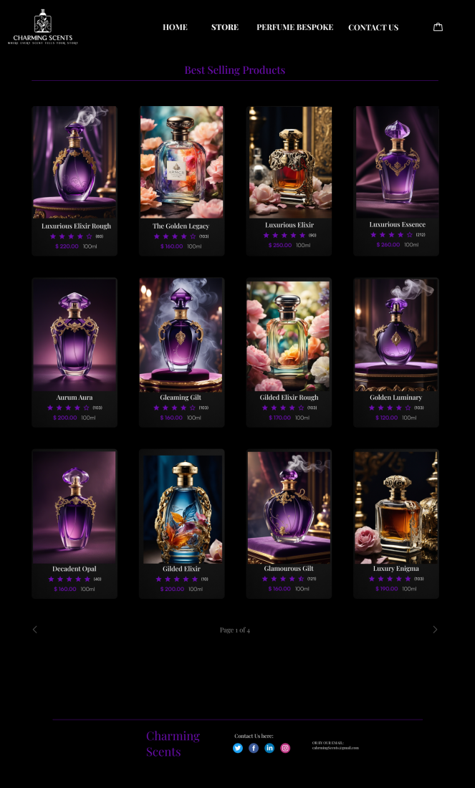
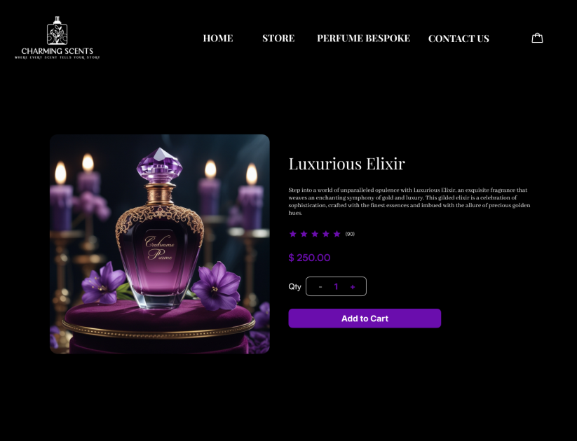
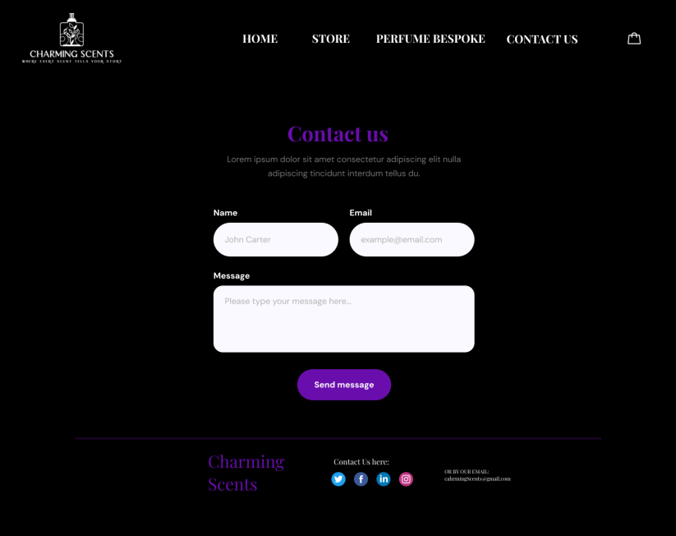
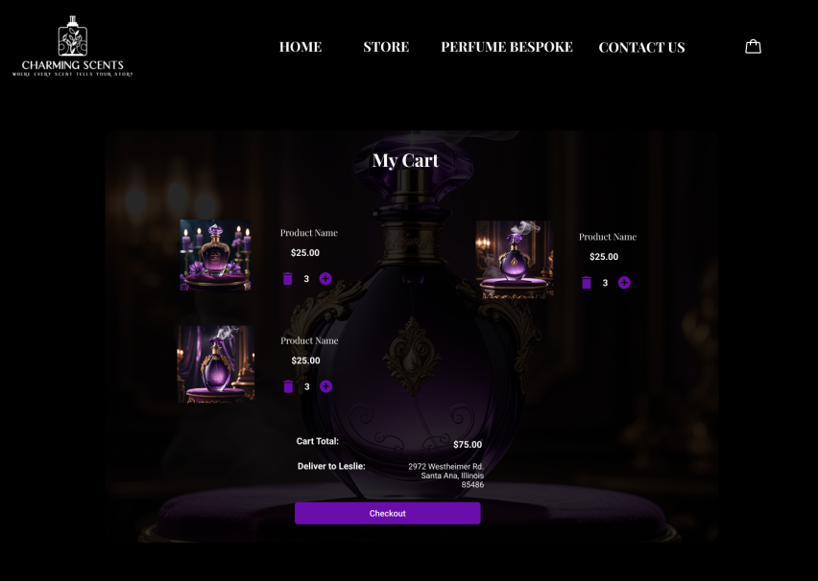
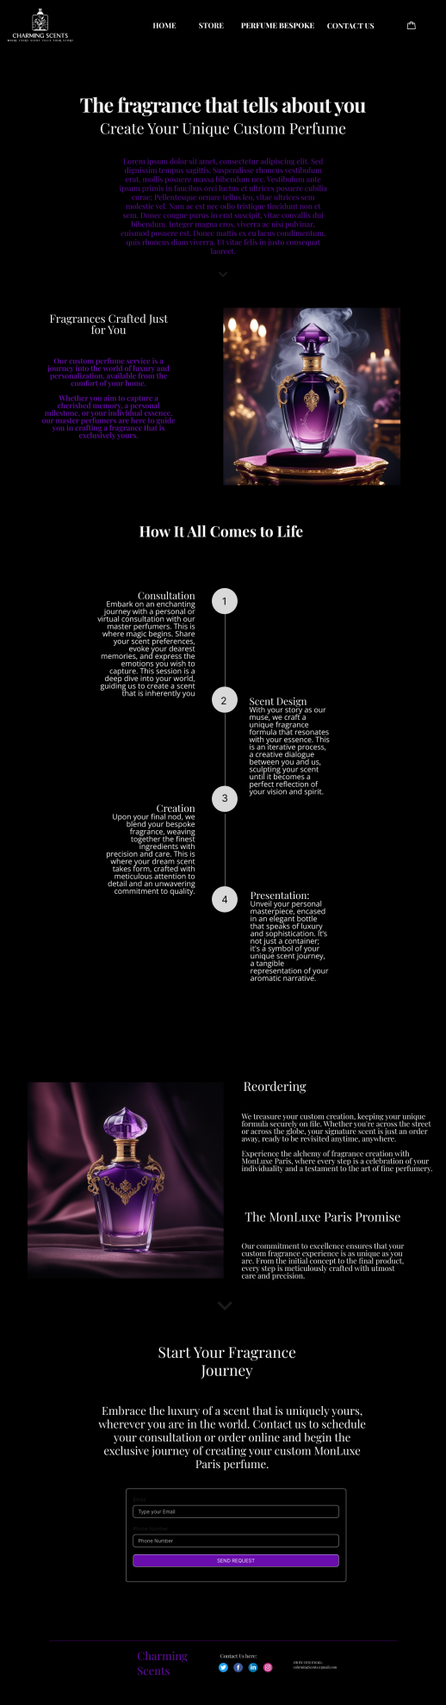
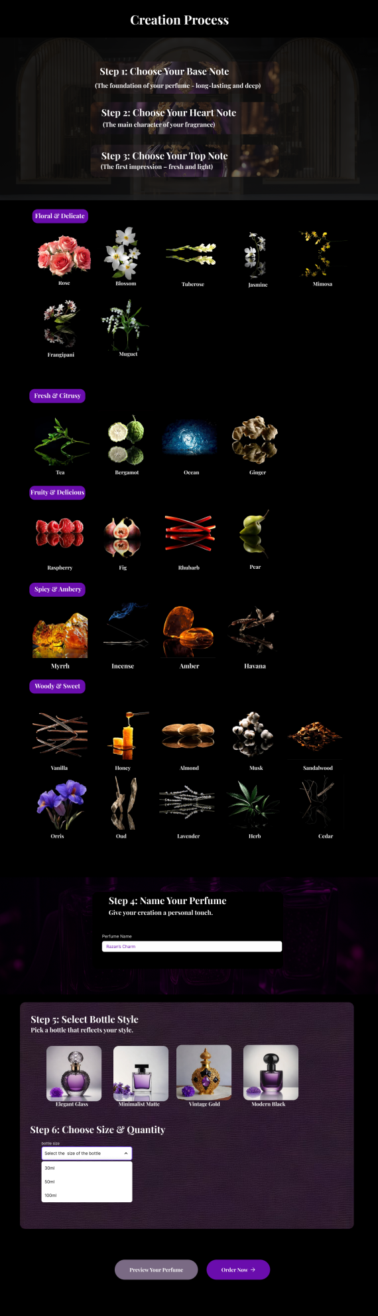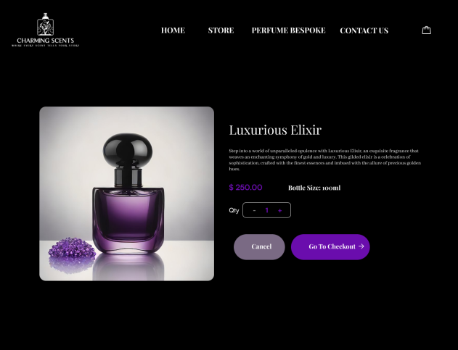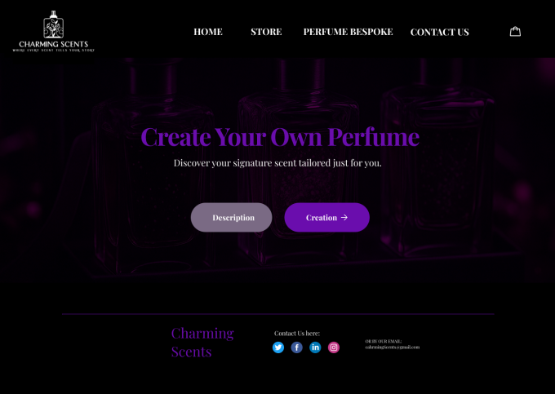

And this is the cover page:
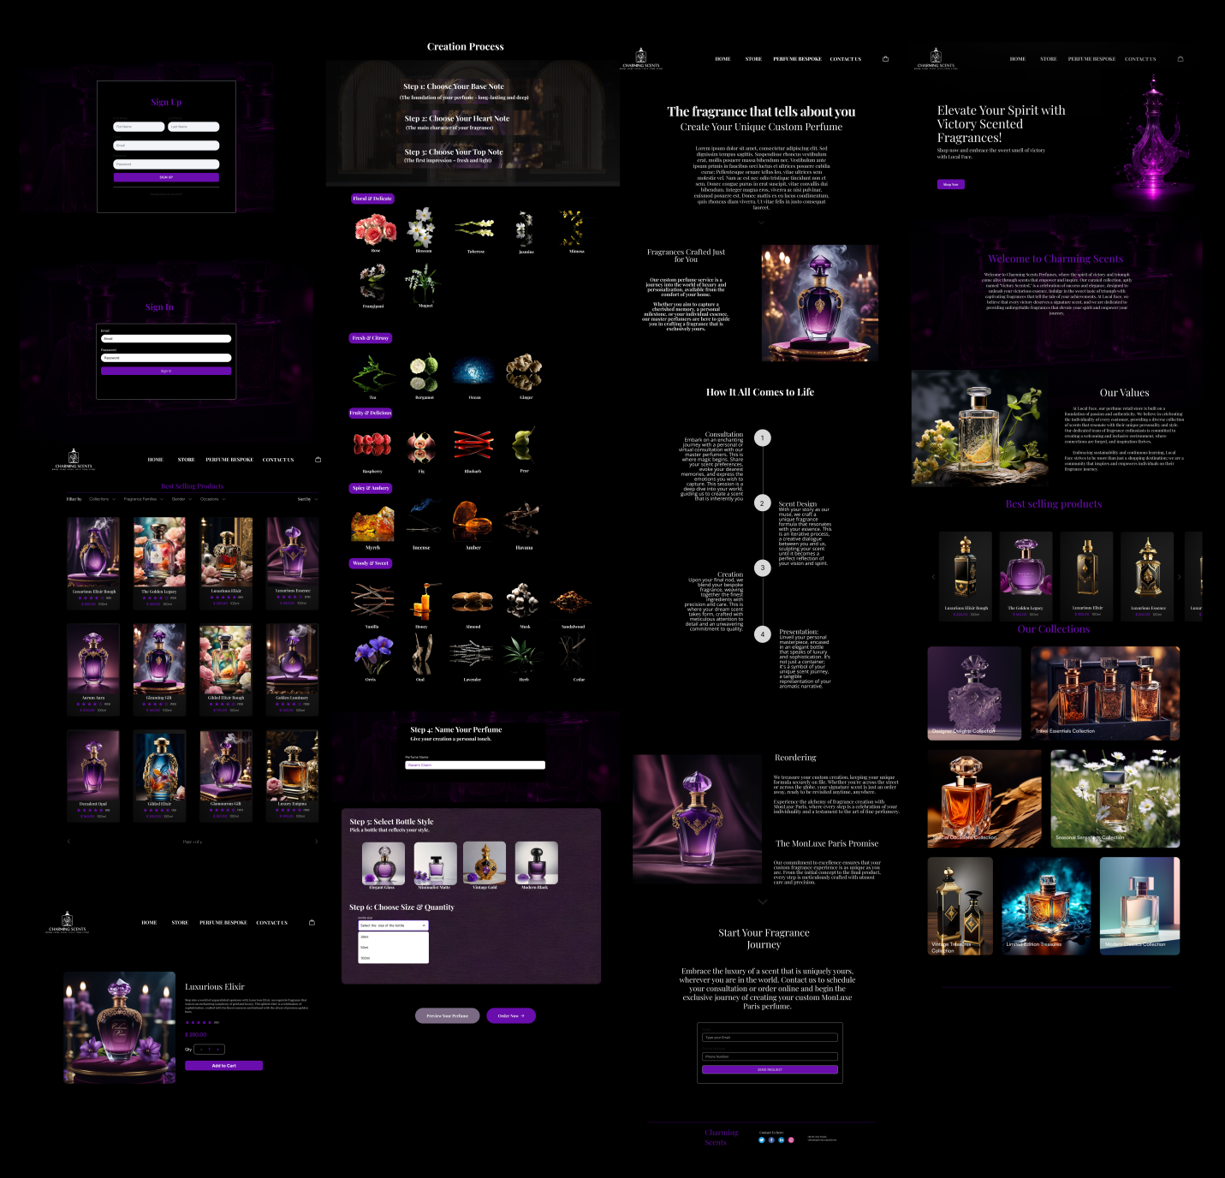

And here is the link of the mockup: https://www.figma.com/design/rBmQ6z2B1v6w0MjHgyOlbE/Untitled?node-id=72-1293&t=wZrj1dANKoQebPiP-1

7.2 Iteration 1

7.2.1 Feedback - outline the end users’ feedback on the first iteration of your Mockup.

Color Scheme

The most popular feedback said that the combination in black and purple was described as being elegant and premium. Still, some users said that a few strings of purple text were difficult to see against the darker backgrounds. (so what they saw that certain purple text was hard to read on dark backgrounds).

Typography is an important aspect, as it affects how well the text is understood and looked at.

For most people, the white font was fine, although several users advised to make the labels bigger and add more space between them to enhance how easy it was to read. (so some users recommended using larger font sizes for the headings and add more spacing between sections).

Call-to-Action Buttons

Many people found out that the “Start Customizing” option was above the logo after using the app for a bit. The suggestion was to use a clearer or bigger outline for the button.

7.3 iteration 2

7.3.1 Feedback- - outline the end users’ feedback on the second iteration of your Mockup.
After applying the first iteration of the feedback, I have updated the mockup and shared it again with the users for the second round of the iteration. And what I have got that the users were fully satisfied with the mockup and they liked the update.
- Buttons that are easier to spot
After the hover effect helps the button stand out, users find it more inviting and easy to notice.

- Better Readability
The content was much simpler to read because the page had a larger font with extra spaces between each line. People noticed an improved difference in color between purple features and the rest of the screen.
- Overall Flow
They felt the first interaction within the website, gave a smooth and current visual experience, just like from a high-end perfume service.

7.4 Screenshots after applying feedback (of the updated mockups only).

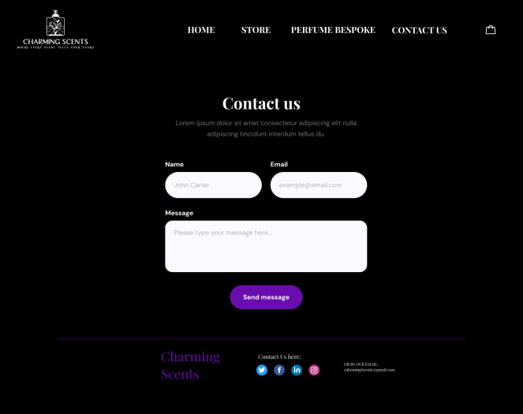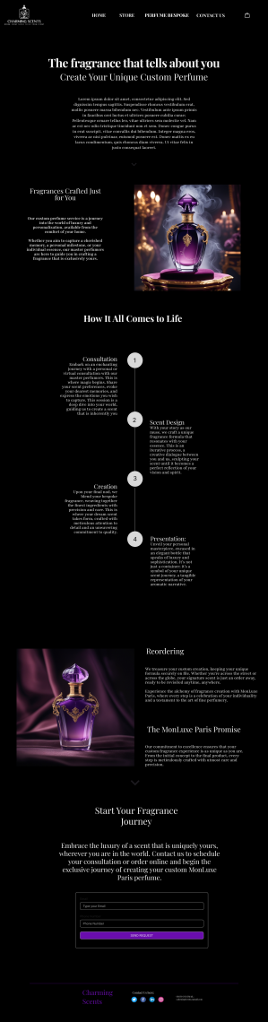
What I changed in the mockup design is the font sizes and its clearness, the buttons and their size and they have an effect to be clearer for users. Also changes some colors. That won’t be noticed from the pictures.
Now we can say that the mockup from the first iteration to the second iteration reflects a clear progress in its appearance, how the users can interact with it, and brand consistency. Based on user feedback, changes and improvements were made to make sure that design looks high-end, operate well, and emotionally engaging. All what is essential for a product that focuses on fashion, creativity, and self-expression.

High-fidelity Prototype

8.1 Outline the added features to build your high-fidelity prototype. (What are the interactions, validations added to your prototype to make it similar to the final product)

The main goal in making the high-fidelity prototype of “Charming Scents” was to make it as similar as possible to the functioning of the website. Unlike what was created before like wireframes and mockups, this prototype gives users a chance to engage with the design by clicking and seeing how it works in real life.
Here are the main features I added to the high-fidelity prototype:
1. Clickable Interactions
Every button, navigation link, and action (for example, “Start Customizing”, “Description”, or “preview”) can be clicked.
Users can go through all the steps in creating a perfume, as the interface copies the look and feel of an app.
2. Hover Effects and small-scale Animations
Buttons and scent options appear to be alive because their hover effects interact with the cursor.
Making the steps or the bottle preview change gradually helps make the app look modern and pleasant.

3. Multi-step Form Flow
The process of creating perfume is divided into small steps that are well marked and it is possible to go forward and backward:
- Step 1: Select Top Note
- Step 2: Select Heart Note
- Step 3: Select Base Note
- Step 4: Name your perfume
- Step 5: Select Bottle Style
- Step 6: choose the size of the bottle
- Step 7: Preview OR order now

All the steps have progress indicators that enable users to know their position in the process.
4. Live Bottle Preview
As the users select the color of the bottle, label text or the shape, the visual preview is updated on the fly.
This makes it feel realistic and interesting and creates an emotional connection to a creation.

5. Carousel Horizontal Scrolling Perfume Line
- The home page has a section where the perfume designs can be scrolled (carousel style).
- The customer does not have to leave the page to see several perfume designs; swiping or clicking arrows helps to change the design.
- This enhances visual interaction and provides the users with inspiration or easy access to top perfumes.
The additional functionality allows making the high-fidelity prototype functional as an actual working site rather than a design. The outcome is a completely interactive and testable version that can be ready to get user feedback, present to a client, or hand off to a developer.

6. Quantity Adjustment Function (Add / Remove Bottles)
An interactive interface was included in the cart or order review page where a user can be able to increment or decrease the quantity of the customized perfume.
- The quantity buttons ( + and - ) are clickable, and the number is changed on the fly.
- To avoid the validation of a quantity less than 1, Visual validation is added.
- This makes the prototype more realistic as it emulates the functioning of a real online ordering system.

Reason it matters:
This option allows the user to have complete control over his order and causes the prototype to act more as an actual e-commerce experience. It also makes the interface ready to be integrated in future with payment and check out systems.

8.2 Review end-user feedback from multiple iterations of your prototype and justify the updates to the final prototype based on end user feedback and testing.

In order to make sure that final prototype of “Charming Scents” will correspond with the needs of users and will offer them satisfying and uncomplicated experience, feedback was gathered and implemented at several stages of the design process: low-fidelity wireframes, mid-fidelity mockups, and high-fidelity prototype.
To come up with a high-fidelity prototype that is most representative of the needs, expectations, behaviors of the target users, I gathered feedback based on three structured evaluation methods: usability testing, A/B testing, and beta testing.

1. Wireframe Iterations Feedback (Low-Fidelity)
Problem: Users were not clear on how to go about with the scent selection process and top/middle/base notes were foreign terms to them.
→ Update: Each step in the creation of perfume now has short tooltips and description.

Problem: Not clear navigation between shop and custom perfume creator.
→ Update: The navbar has been reorganized into two different sections including "Shop" and "Create Your Own".

Problem: The users claimed there was no sense of direction in the home page.
→ Update: It now contains a large CTA button with the text Start Creating that helps direct the user towards the custom design process.

2. Mockup Iterations Feedback (Mid-Fidelity)
Problem: Certain purple text proved illegible against dark backgrounds.
→ Update: Added better contrast, Modifying the background colors and making the text of headings and buttons white.

Problem: Users perceived that the Start Creating button was not prominent enough.
→ Update: The CTA button now has a gold border and a hover effect, as well as a bold font to make it more visible.

Problem: The perfume creation process lacked good flow indicators as requested by the users.
→ Update: Included a step progress bar that tells the user his/her progress in the customization process.

3. High-Fidelity Prototype Feedback
Problem: Not all users were aware of the possibility to scroll the line of perfume products.
→ Update: I have included some horizontal scroll arrows and a little animation on the carousel to make it more apparent and interactive.

Problem: Users demanded to see the design of the bottle during customization.
→ Update: It was implemented to have a live bottle preview section that will change in real time as the user chooses the shape, color and label of the bottle.

1. Usability Testing (Low and Mid-Fidelity /Early Iterations)
Usability testing sessions Usability testing sessions were carried out both in-person and remotely with a small focus group of 6 participants that matched the target demographic:
- How carried out:
- The low and mid-fidelity versions of the wireframe and the mockups were tested by users who were requested to complete certain tasks.
- They were watched without being noticed and their flow of navigation, the points where they got confused and their reactions were noted.
- The session was followed by a debrief in which the users were allowed to comment on what they liked, disliked and what can be done to improve it.
2. A/B Testing (Mid-Fidelity - Design Decisions)
Two variants of the design of important interface elements were tested with A/B testing to be able to make objective decisions based on the preference of users.
- How it was done:
- There were two sets of particular screens (e.g., cart / sign in/up pages) designed.
- I kept a note of which version resulted in quicker completion of the task, greater comprehension, and superior satisfaction.
As a part of the evaluation process, I performed A/B testing on two most important pages of the site Cart Page and Sign In/Sign Up Page. Regarding each section, I created two variation layouts (Version A and Version B) that are different in the layout, the position of buttons, and general visual flow. I then tested both versions with different users and noted which one offered a better experience, was more clear, and offered easier interaction. With the help of the feedback and behavior of the users, I was able to choose the more successful versions of it, namely, the layouts that were perceived by the users as more intuitive, visually uncluttered and more convenient to use. This approach to testing assisted me in making confident data-driven design choices and enhanced the general usability of the platform.
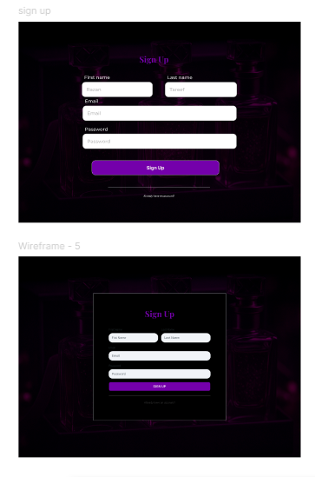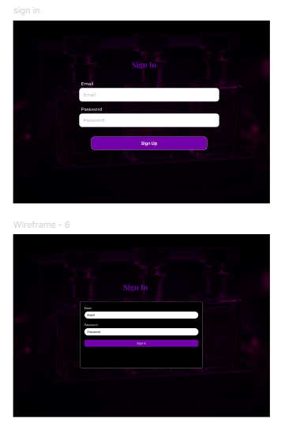

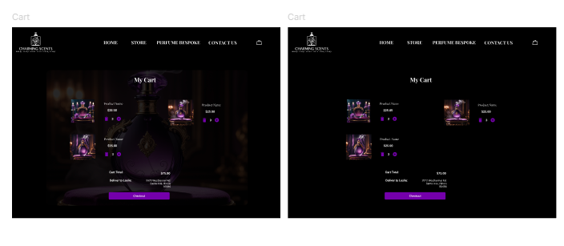
3. Beta Testing ( Final High-Fidelity Prototype)
After implementing the last prototype and making it fully interactive and visually complete, I did a round of beta testing with a small user group (5 people) to emulate real use of the platform.

- How it was done:
- The high-fidelity prototype was sent as a clickable Figma link.
- The users were requested to complete the entire journey: homepage -> custom perfume flow -> etc.
- I then took note of how they would interact with the prototype without any instructions and compiled final feedback basing on their entire experience.

- Justification of Final Updates
User feedback collected using all three techniques directly influenced the final prototype. All the updates have been done with real user interaction and not assumptions which makes the product user oriented and accessible.
These testing rounds helped me to:
- Clarify the information architecture and navigation
- Enhance visual readability and contrast
- Put in confirmation steps and on-line feedback
- Improve the emotional engagement generally with personalization features
Consequently, the high-fidelity prototype has been evolved to provide a full, intuitive and emotionally compelling experience, that matches the project objectives and end user needs.

Critically evaluate the prototype against the original plan and how user feedback and testing was implemented.

“Charming Scents” was initially conceived as an interactive web experience where people can create their own personalized perfume by blending scent notes, designing their own bottle, naming their perfume and seeing a preview of their creation before saving it.
When going through the design and prototyping process I tried to be as close as possible to this vision but I remained open and adaptive to user feedback collected through a variety of testing mechanisms such as usability testing, A/B testing, and beta testing.
In This section I will critically evaluate the resulting high-fidelity prototype in comparison with the original plan and describes how direct user testing influenced the final result.
I will dive into this evaluation to go through everything that I did in this project:
1. Original Plan vs Final Prototype

Original Plan | Final Outcome | Evaluation
Users can mix scents (Top, Middle, Base Notes) | Implemented with guided steps and descriptions | Achieved and improved through user feedback (tooltips, step-by-step navigation)
Users can customize the perfume bottle | Added with live preview of shape, color, and label | Fully achieved and praised by beta testers
Users can name their perfume | Interactive Input field with validation. | Achieved with better UX and emotional impact
Homepage clearly guides users | Originally unclear; improved after feedback | Now includes bold CTA “Start Customizing” and better structure
Visual elegance (black, purple, with white font) | Used consistently with white fonts for contrast | Improved after A/B testing showed text contrast issues

2. How did I Implement User Feedback:
- Usability Testing
- What it found out: The process of selecting scents was not fully clear to users.
- My changes: Included descriptions of the scent, added some easy tooltips, and rearranged the steps to make sense.
- What I added: A large, bordered CTA button ("Start Customizing") to guide the users into the customization process.

- A/B Testing
- What I found out: Version A of smell selection design (everything on a single screen) was perplexing.
- What I did: I decided to use Version B - divided each scent layer into a different step, which made the process easier and smoother to follow.
- What I changed: Adjusted position of the buttons, introduced contrast and visual priority to boost interaction.

- Beta Testing
- What it found out: Not all users were aware that the line of perfumes could be scrolled.
- What I did: Enabled horizontal arrows and a little bit of animation on the scrollable carousel section.
- What I did: I adjusted the positioning, margins, and text sizes to be mobile-friendly on different screens.

3. Critical Reflection on Design
The main concept of the app did not change considerably over time, but the prototype transformed a lot due to the constant testing and consideration of feedback:
- At the beginning, I mainly concentrated on the visual design, however, user tests helped me realize that it is also essential to have clarity, space, and step-by-step progress.
- I got to know that interactive elements such as progress bars, hover states, and live previews increase user interaction and confidence.
- I also understood that design should always respond to the user expectation.
This cyclic process led to the fact that my final prototype was not only visually pleasing but also convenient in use, adaptive and reasonable.
In conclusion:
It can be considered that the final prototype bears a high level of similarity with the initial plan, yet it also demonstrated visible evolution and advancement based on the real user behavior and feedback.
All significant enhancements, starting with the easier scent selection process and ending with the improved user experience, were adopted in reference to what users needed and wanted. This confirms that an early and continuous involvement of users in the design process results in improved product quality and increases satisfaction.
Although this process did not result in a final prototype as I had envisioned, I feel that it did assist in creating a stronger final prototype in addition to making me more conscious of how to develop human-centered digital experiences in future projects.

References

- https://teamhub.com/blog/understanding-prototyping-in-software-development-a-comprehensive-guide/
- https://measuringu.com/ab-testing/
- https://www.betterbugs.io/blog/what-is-an-end-user
- https://www.geeksforgeeks.org/difference-between-prototype-model-and-rad-model/

